3A - Measurement – Lesson 02
Units and Applications – Significant Figures etc

Name: _________________
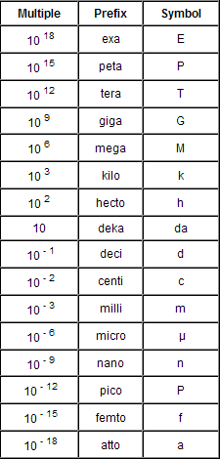

Standard Prefixes

- We measure a bottle of coke as 600 mL. What does the ‘m’ stand for here?

- A pencil is 3 dm long. What is the word that the prefix ‘d’ stands for?

- My old hard drive is 320 gigabytes but my new hard drive is 1.8 terabytes. What prefixes would I use?

- A hair’s thickness is 50 to 120 μm. What does the symbol μ stand for?

Significant Figures

- Why do we use significant figures?
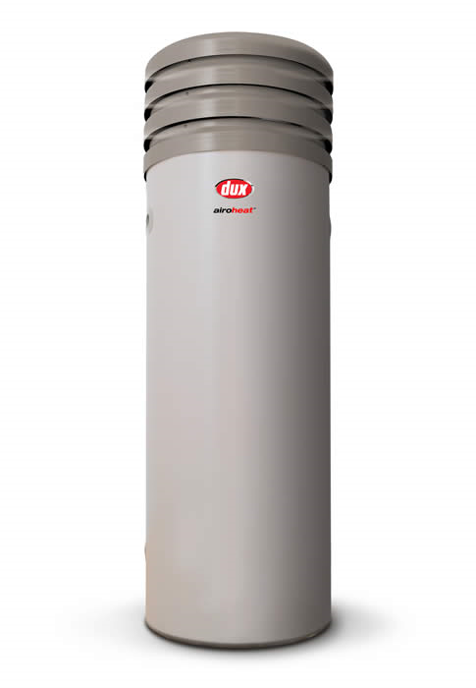

- I used trigonometry to calculate that the lean on my water tank was 9.46375 degrees. It is only reasonable to give the answer to two significant figures. What would the angle be rounded to?

- The water in a lake is measured as 50 ML. What does the ‘M’ stand for?

- The latest hard drives have 1.6 petabytes. How many zeros would there be if we measures the capacity and bytes? (Watch out, trick question.)

Scientific Notation

- Why do we use scientific notation?

- The weight of a car was given as 1 375 000 grams. Write this in scientific notation.
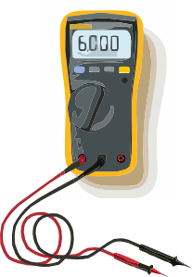

- An electrician measured the current in a circuit as 0.0005 Amps. Write this as a number in scientific notation.

- The Australian budget is $52 billion dollars. What is this in scientific notation?

- A plumber measures the flow of water through a pipe as 1.4 x 10³ Litres per hour. Use your calculator to change it to normal notation.


- The solar power unit on a house’s roof is 1.25 x 10³ watts. Use your calculator to change it to normal notation.

